Kubernetes Task-09
- Execute all the steps shown in video.
- Upgrade k8s cluster from 37.0 to 37.1 Version. Note: Document to upgrade cluster. https://devopscube.com/upgrade-kubernetes-cluster-kubeadm/
PART 1 — Kubernetes Ingress Lab
Architecture we are going to build
Browser
|
| http://example.com
v
+-------------------+
| Ingress Controller |
| NGINX |
+-------------------+
|
| Ingress Rule
v
+-------------------+
| nginx-service |
| :80 |
+-------------------+
|
v
+-------------------+
| nginx Pod |
| :80 |
+-------------------+
Ingress itself is only the Kubernetes API resource containing routing rules; an Ingress Controller must actually implement those rules.

Step 1 — Check your current cluster
Run this on your control-plane node:
kubectl get nodes -o wide
Then:
kubectl version
Then:
kubectl get pods -A
You should see your control-plane and worker nodes.
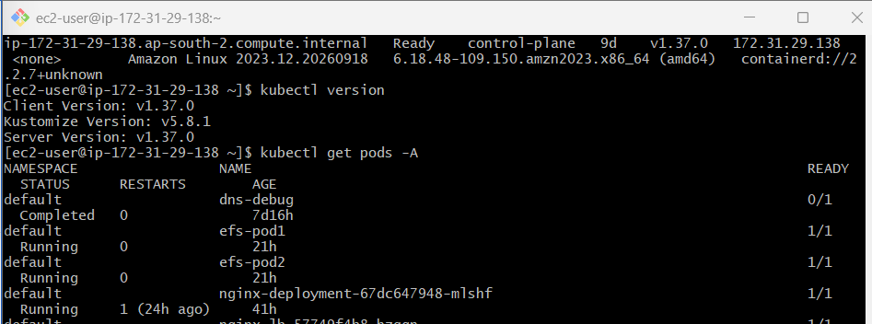
Also check whether an Ingress Controller already exists:
kubectl get pods -A | grep -i ingress
And:
kubectl get ingressclass
Do not install another controller if one is already running.
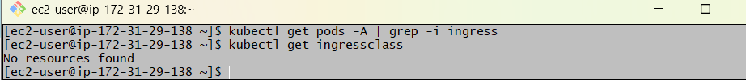
This confirms your current cluster does not have an Ingress Controller installed yet:
kubectl get pods -A | grep -i ingress
→ no output

kubectl get ingressclass
→ No resources found
So we can install the NGINX Ingress Controller next.
Step 1 — Install NGINX Ingress Controller
Because your cluster is an AWS kubeadm cluster, don't use:
minikube addons enable ingress
That command is only for Minikube.
For your cluster, run:
kubectl apply -f https://raw.githubusercontent.com/kubernetes/ingress-nginx/controller-v1.13.3/deploy/static/provider/baremetal/deploy.yaml
Then wait about 30–60 seconds and run:
kubectl get pods -n ingress-nginx
Then:
kubectl get svc -n ingress-nginx
And:
kubectl get ingressclass
What we expect
You should eventually see something similar to:
NAME READY STATUS
ingress-nginx-controller-xxxxxxxxx 1/1 Running
and:
NAME
nginx
for the IngressClass.
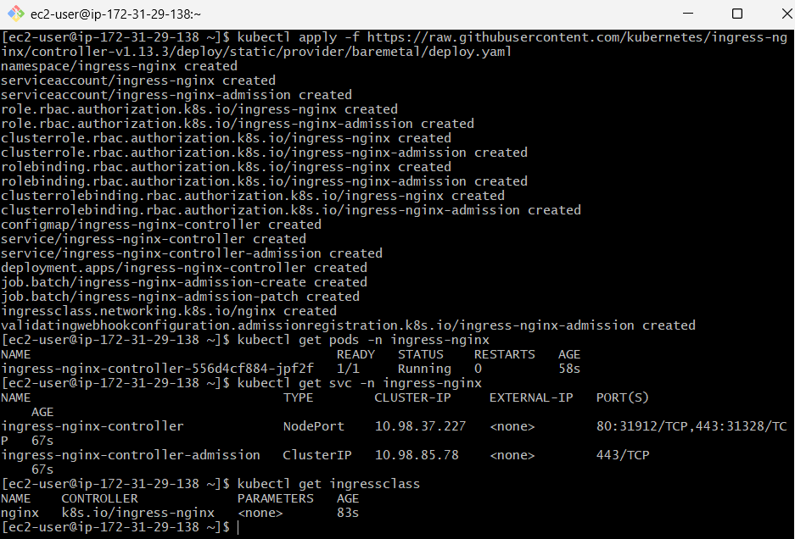

Step 2 — Create a working directory
mkdir -p ~/kubernetes-ingress
cd ~/kubernetes-ingress

Step 3 — Create the Deployment
Create:
vi deployment.yml
Put this:
apiVersion: apps/v1
kind: Deployment
metadata:
name: nginx-deployment
spec:
replicas: 2

selector:
matchLabels:
app: nginx

template:
metadata:
labels:
app: nginx

spec:
containers:
- name: nginx
image: nginx:latest
ports:
- containerPort: 80
Save:
ESC
:wq
ENTER
Apply:
kubectl apply -f deployment.yml
Check:
kubectl get deployment
Expected:
NAME READY UP-TO-DATE AVAILABLE
nginx-deployment 2/2 2 2
Check Pods:
kubectl get pods -o wide
You should have two nginx Pods.
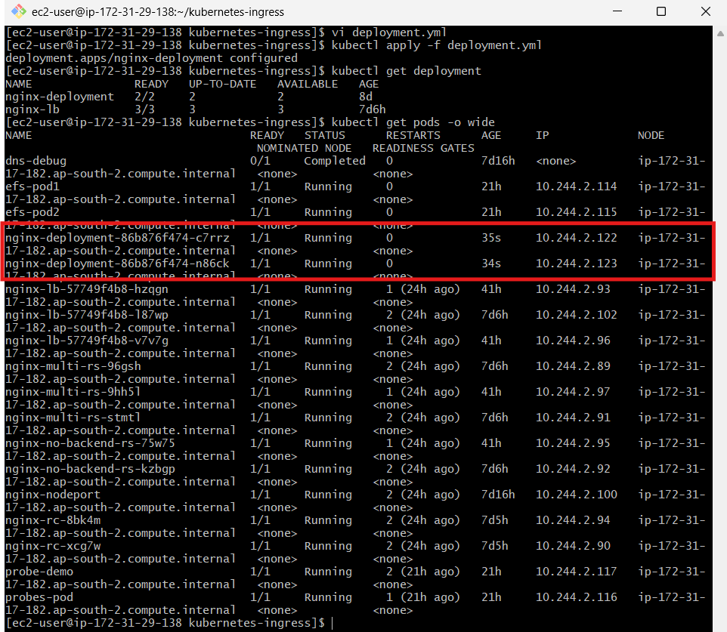

Step 4 — Test the Deployment
Run:
kubectl describe deployment nginx-deployment
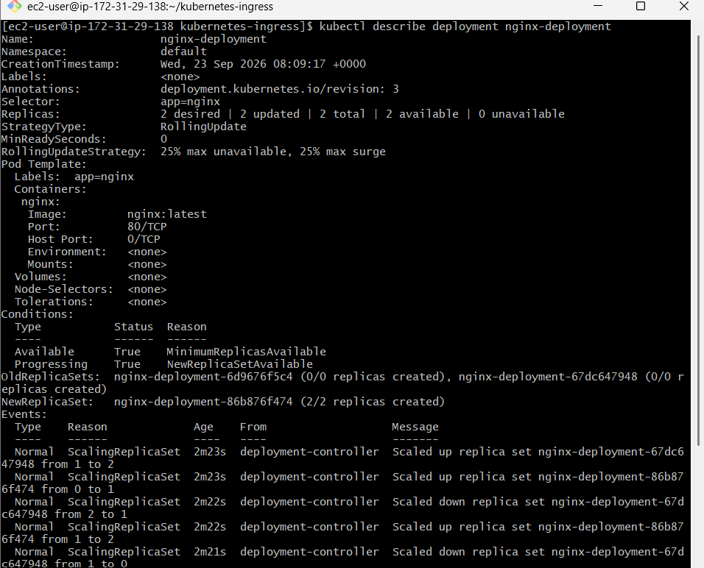
Then:
kubectl logs -l app=nginx
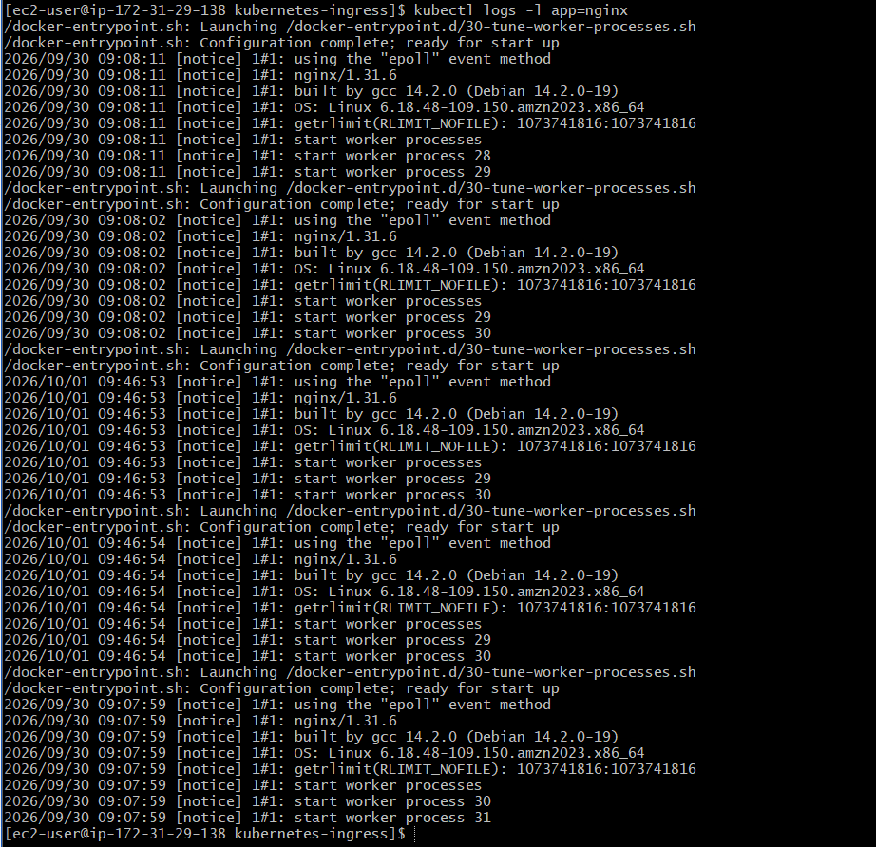
You can also check the Pod:
kubectl exec -it <POD-NAME> -- nginx -v
For example:
kubectl exec -it nginx-deployment-xxxxx -- nginx -v
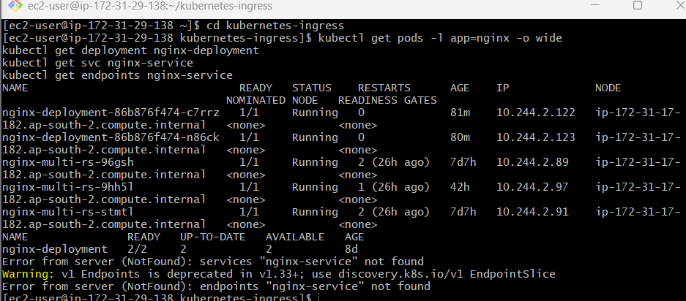

Step 5 — Create the Service
Create:
vi service.yml
Use:
apiVersion: v1
kind: Service
metadata:
name: nginx-service

spec:
selector:
app: nginx

ports:
- protocol: TCP
port: 80
targetPort: 80

type: ClusterIP
Important
Your video uses:
type: NodePort
nodePort: 30001
That works, but for an Ingress architecture, ClusterIP is normally sufficient because the Ingress Controller routes to the Service internally.
Apply:
kubectl apply -f service.yml
Check:
kubectl get svc
Expected:
NAME TYPE CLUSTER-IP PORT(S)
nginx-service ClusterIP 10.xxx.xxx.xxx 80/TCP
Check endpoints:
kubectl get endpoints nginx-service
You should see your nginx Pod IPs.
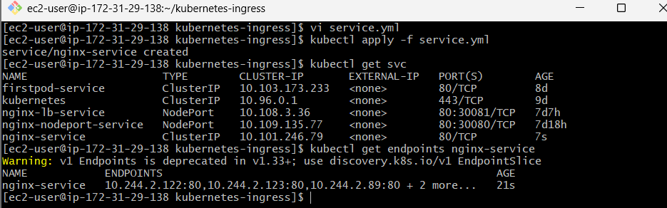

Step 6 — Test Service connectivity
First get the Service IP:
kubectl get svc nginx-service
Then:
kubectl describe svc nginx-service
Most importantly:
kubectl get endpoints nginx-service
If endpoints are present, the Service is correctly connected to the nginx Pods.
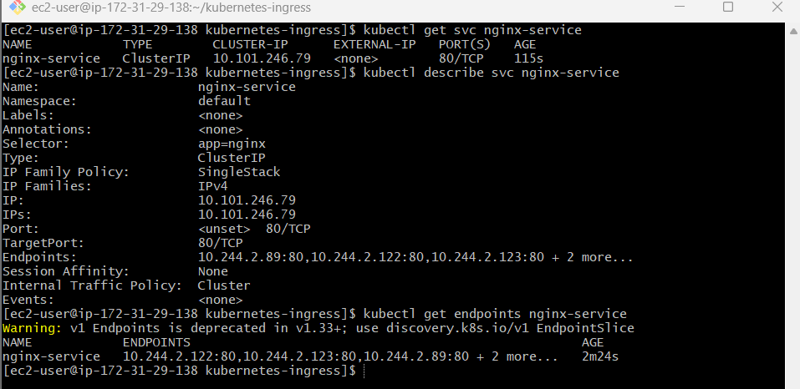

Step 7 — Install an Ingress Controller
Your video specifically discusses NGINX.
For Minikube, the video command is:
minikube addons enable ingress
Then:
kubectl get pods -n ingress-nginx
However, your main lab environment has been an AWS kubeadm cluster, not Minikube. So don't run minikube addons enable ingress on that cluster.
For the AWS/kubeadm cluster, we need an NGINX Ingress Controller appropriate for that environment.
Before installing anything, run:
kubectl get ingressclass
and:
kubectl get pods -A | grep ingress
Send me the output of those two commands.
I'll then give you the exact controller installation for your current cluster rather than risking a conflicting controller.
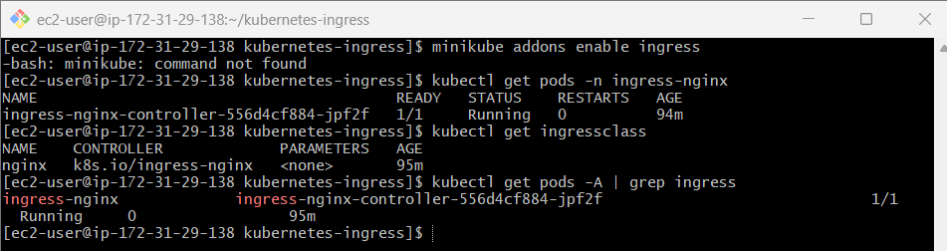

Step 8 — Create the Ingress
Once the NGINX controller is ready, create:
vi ingress.yml
Use this slightly improved version of your video's YAML:
apiVersion: networking.k8s.io/v1
kind: Ingress
metadata:
name: nginx-ingress

spec:
ingressClassName: nginx

rules:
- host: example.com

http:
paths:
- path: /
pathType: Prefix

backend:
service:
name: nginx-service
port:
number: 80
The ingressClassName: nginx explicitly tells Kubernetes which Ingress Controller should handle this Ingress. The current Kubernetes documentation recommends specifying the Ingress class.
Apply:
kubectl apply -f ingress.yml

Step 9 — Verify Ingress
Run:
kubectl get ingress
Then:
kubectl describe ingress nginx-ingress
Also:
kubectl get ingress nginx-ingress -o yaml
You want to eventually see an address associated with the Ingress Controller.
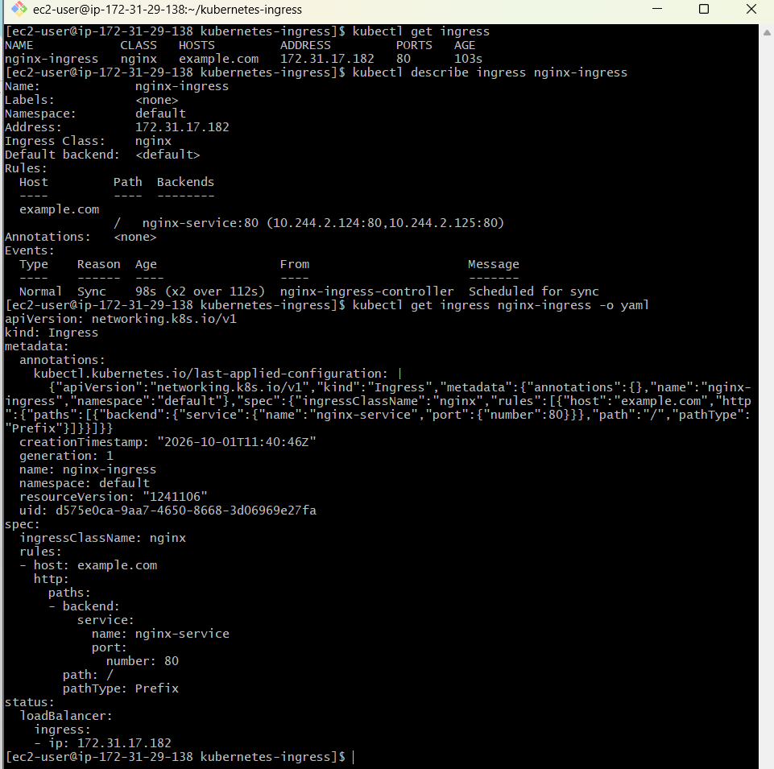

Step 10 — Test example.com
Because example.com is just the hostname in your lab YAML, your computer needs to send that hostname to your Ingress Controller's address.
First find the Ingress Controller Service:
kubectl get svc -A | grep -i ingress
Depending on the controller installation, you may see something like:
ingress-nginx-controller NodePort
or:
ingress-nginx-controller LoadBalancer
We'll use the actual result from your cluster to determine the test command.
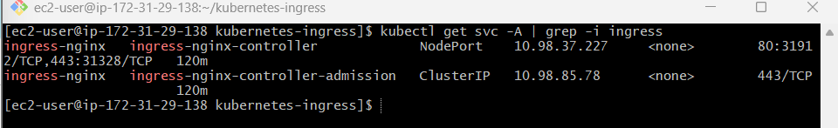

Step 11 — Test using curl
For example, if your Ingress Controller is reachable at:
<INGRESS-IP>
you can test the Host header directly:
curl -H "Host: example.com" http://<INGRESS-IP>/
Expected response:
<!DOCTYPE html>
<html>
<head>
<title>Welcome to nginx!</title>
...
This proves:
curl
|
| Host: example.com
v
Ingress Controller
|
v
Ingress Rule
|
v
nginx-service
|
v
nginx Pod
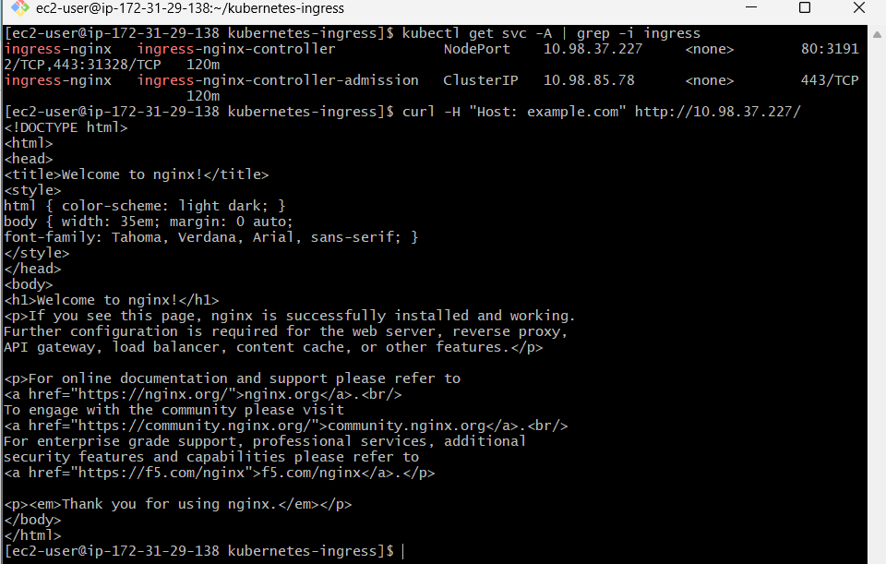

Step 12 — Test with /etc/hosts
If you're testing from your laptop and have an accessible Ingress IP, you can add:
<INGRESS-IP> example.com
to your local hosts file.
On Windows:
C:\Windows\System32\drivers\etc\hosts
Then:
<INGRESS-IP> example.com
After that:
http://example.com
should reach the Ingress Controller.
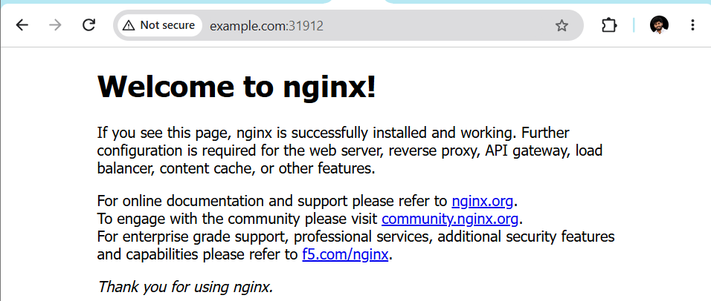
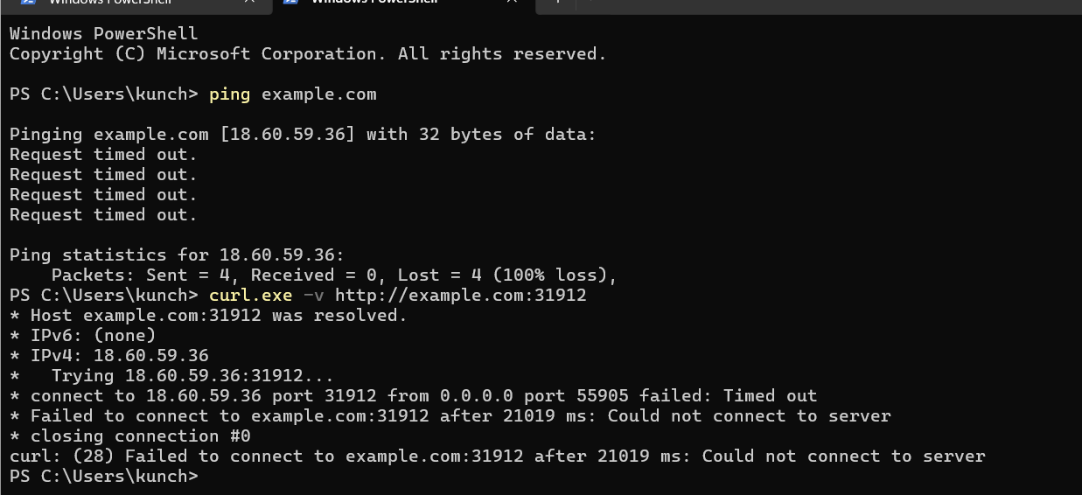
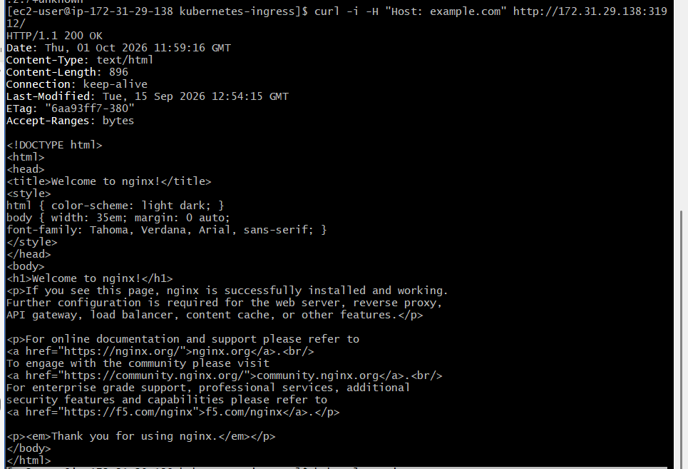

Step 13 — Verify the complete Ingress chain
Run these commands:
kubectl get deployment
kubectl get pods -o wide
kubectl get svc
kubectl get endpoints
kubectl get ingress
kubectl get ingressclass
kubectl get pods -A | grep ingress
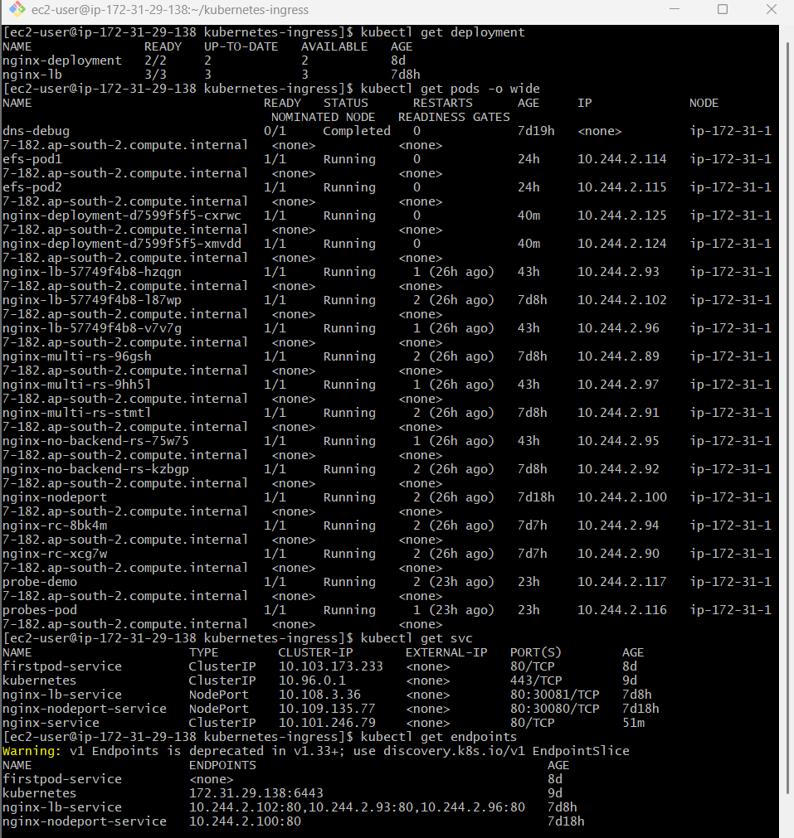
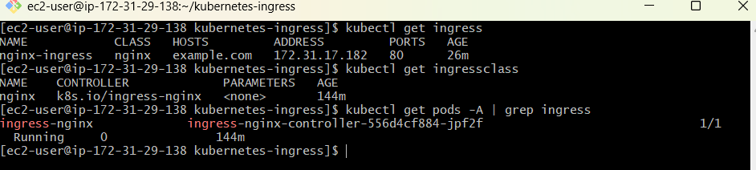
Your final architecture should be:
CLIENT
|
| HTTP
v
+---------------------+
| NGINX INGRESS |
| CONTROLLER |
+---------------------+
|
| Host = example.com
| Path = /
v
+---------------------+
| nginx-ingress |
| Kubernetes Resource |
+---------------------+
|
v
+---------------------+
| nginx-service |
| ClusterIP :80 |
+---------------------+
|
+-------+-------+
| |
v v
nginx Pod nginx Pod

PART 2 — Kubernetes 37.0 → 37.1 Upgrade
Now we move to the second assignment.
VERY IMPORTANT
Your existing cluster is:
Amazon Linux 2023
Kubernetes v1.37.0
So DO NOT execute:
kubeadm upgrade apply v1.28.x
on it.
That would be a downgrade, not the requested upgrade.
For a genuine:
1.26 → 1.28
exercise, we need a cluster currently running:
1.26.x
The supported upgrade path is:
1.26.x
|
v
1.27.x
|
v
1.28.x
Kubernetes' kubeadm documentation explicitly states that skipping minor versions is unsupported.

Upgrade Lab — Step 1
On the 1.26 control-plane node, document the existing state.
kubectl get nodes -o wide
kubectl version
kubeadm version
kubelet --version
kubectl get pods -A
Save the output for your assignment.
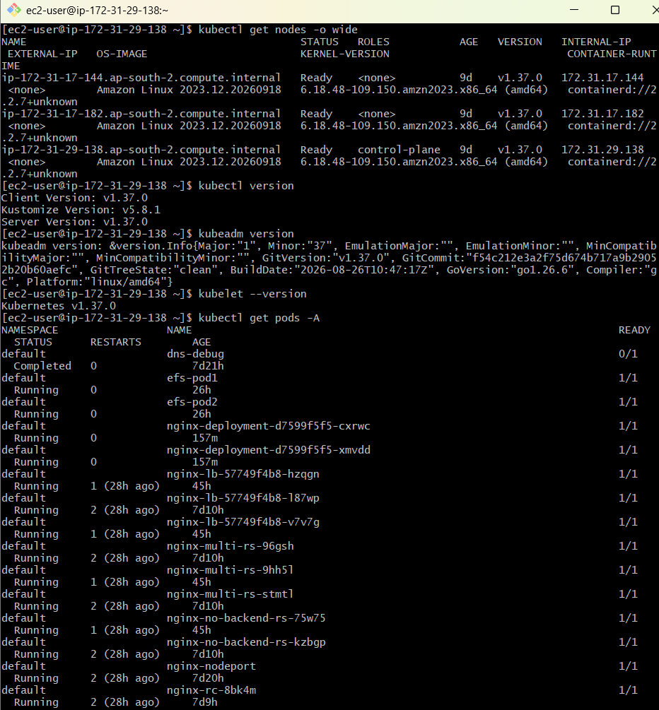

Step 2 — Check cluster health
kubectl get nodes
All nodes should ideally be:
Ready
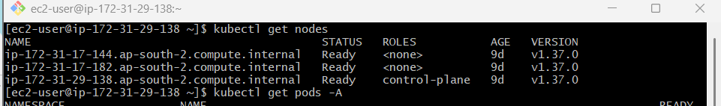
Then:
kubectl get pods -A
Look for failed Pods:
kubectl get pods -A | grep -v Running
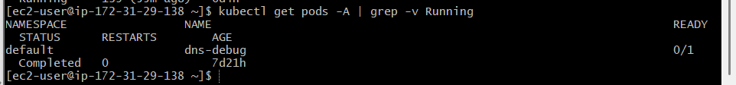

Step 3 — Backup important information
At minimum, record:
kubectl get nodes -o wide > nodes-before-upgrade.txt
kubectl get pods -A > pods-before-upgrade.txt
kubectl get svc -A > services-before-upgrade.txt
kubectl get deployments -A > deployments-before-upgrade.txt
For a production cluster, application/data backups should also be considered before upgrading. The official documentation recommends backups as a best practice.
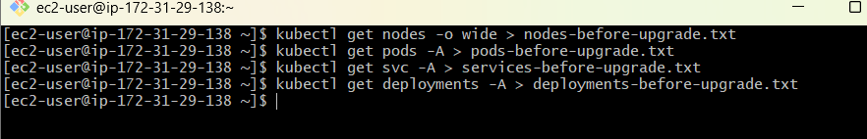

Step 4 — Upgrade Control Plane
On control plane 172.31.29.138:
sudo kubeadm upgrade plan
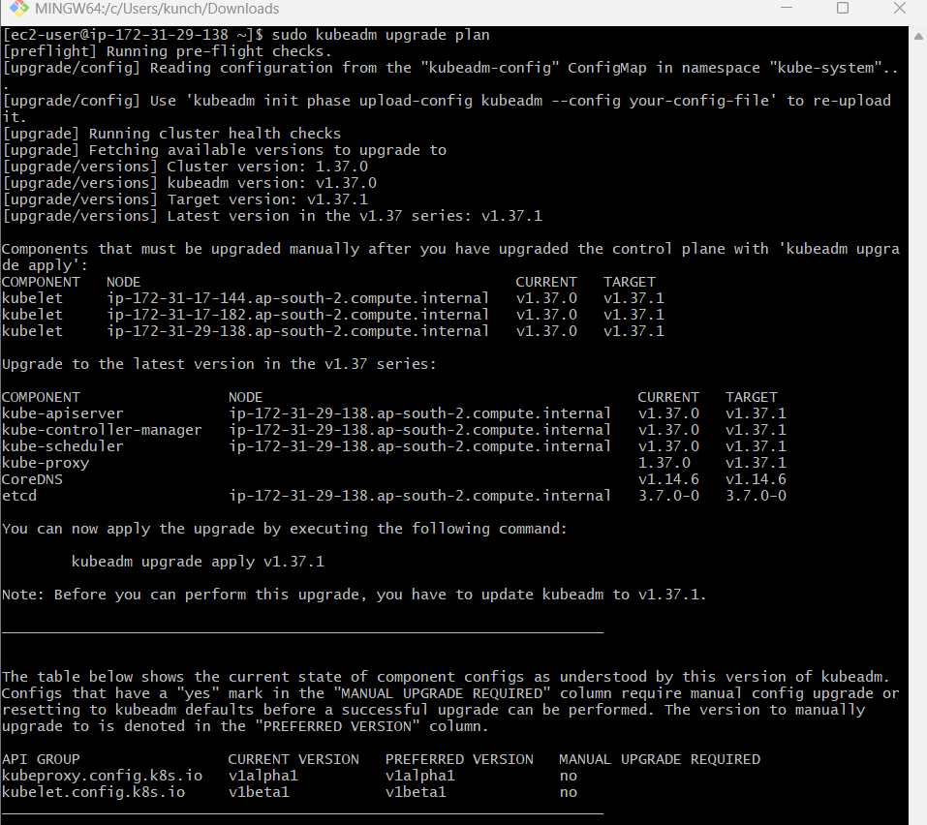
Confirm that the target is:
v1.37.1
Then:
sudo kubeadm upgrade apply v1.37.1
Enter:
y
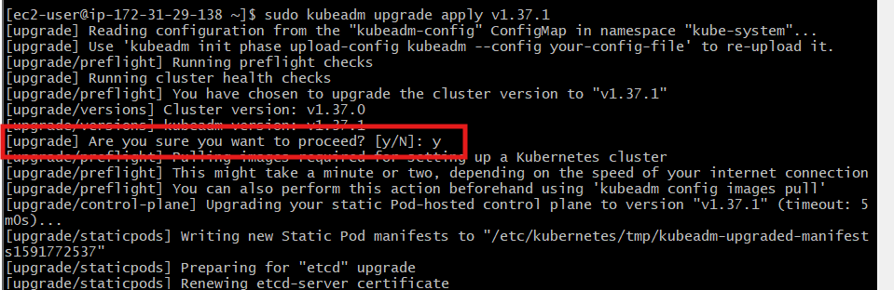
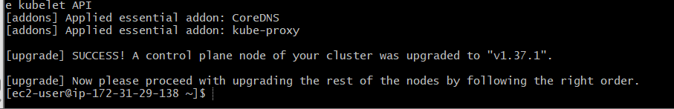

Step 5 — Upgrade Control Plane kubelet
sudo dnf install -y kubelet-1.37.1 --disableexcludes=Kubernetes
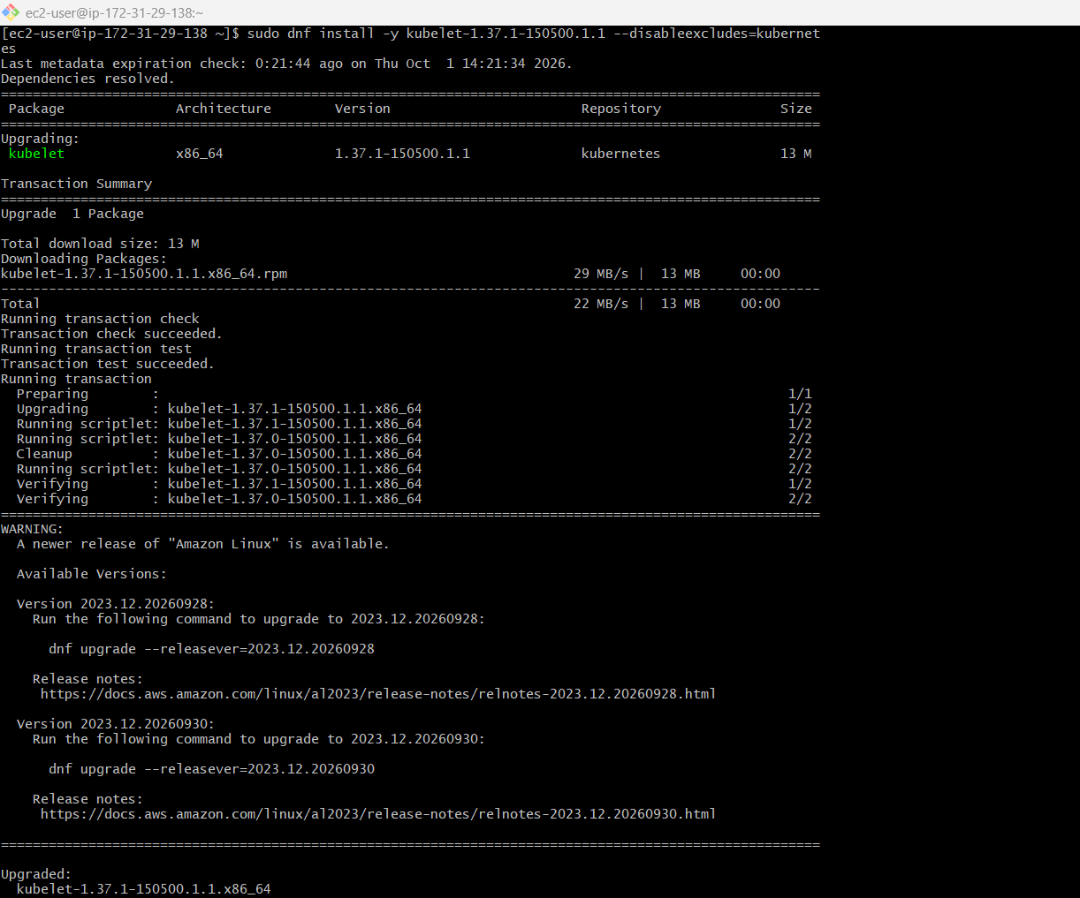
Then:
sudo systemctl daemon-reload
sudo systemctl restart kubelet
Verify:
kubelet --version
Expected:
Kubernetes v1.37.1
Then:
kubectl get nodes
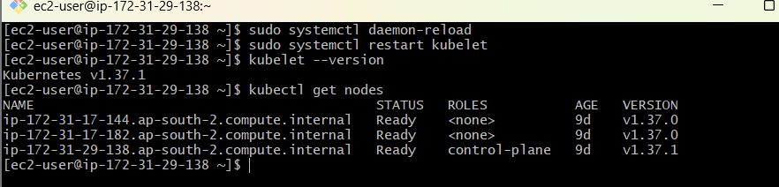

Step 6 — Drain Worker 1
From the control plane:
kubectl drain ip-172-31-17-144.ap-south-2.compute.internal \
--ignore-daemonsets \
--delete-emptydir-data
Then SSH into Worker 1:
172.31.17.144
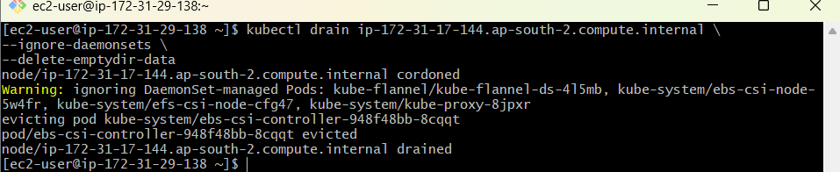

Step 7 — Upgrade Worker 1
On Worker 1:
sudo dnf install -y kubeadm-1.37.1 --disableexcludes=kubernetes
Then:
sudo kubeadm upgrade node
Install kubelet:
sudo dnf install -y kubelet-1.37.1 --disableexcludes=kubernetes
Restart:
sudo systemctl daemon-reload
sudo systemctl restart kubelet
Verify:
kubelet --version
Expected:
Kubernetes v1.37.1
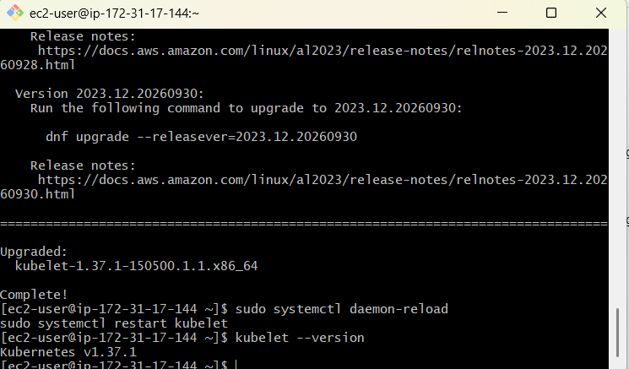

Step 8 — Uncordon Worker 1
Go back to the control plane:
kubectl uncordon ip-172-31-17-144.ap-south-2.compute.internal
Check:
kubectl get nodes
Worker 1 should become:
Ready v1.37.1
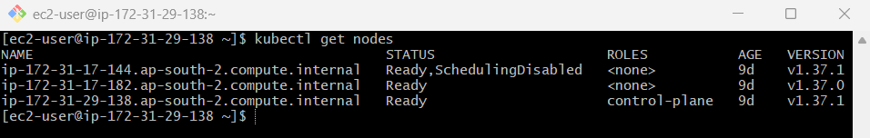

Step 9 — Upgrade Worker 2
Drain:
kubectl drain ip-172-31-17-182.ap-south-2.compute.internal \
--ignore-daemonsets \
--delete-emptydir-data
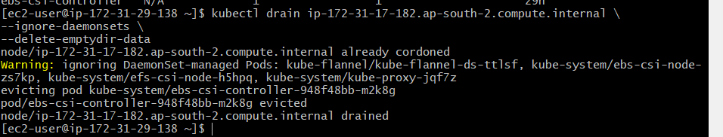
SSH to Worker 2 and run:
sudo dnf install -y kubeadm-1.37.1 --disableexcludes=kubernetes
sudo kubeadm upgrade node
sudo dnf install -y kubelet-1.37.1 --disableexcludes=kubernetes
sudo systemctl daemon-reload
sudo systemctl restart kubelet
Verify:
kubelet –version
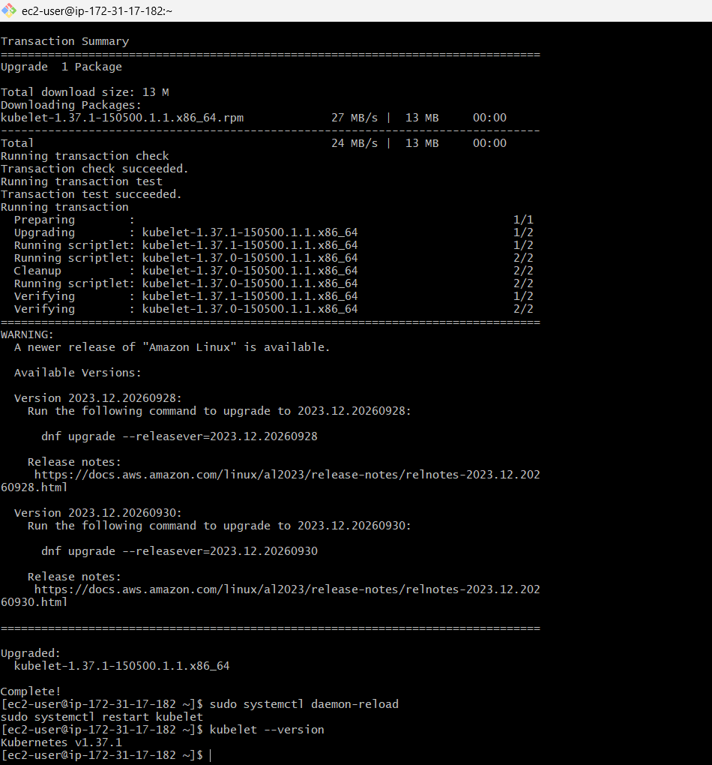

Step 10 — Uncordon Worker 2
On control plane:
kubectl uncordon ip-172-31-17-182.ap-south-2.compute.internal

Step 11 — Final Verification
kubectl get nodes -o wide
You want:
NAME STATUS ROLES VERSION
ip-172-31-29-138... Ready control-plane v1.37.1
ip-172-31-17-144... Ready <none> v1.37.1
ip-172-31-17-182... Ready <none> v1.37.1
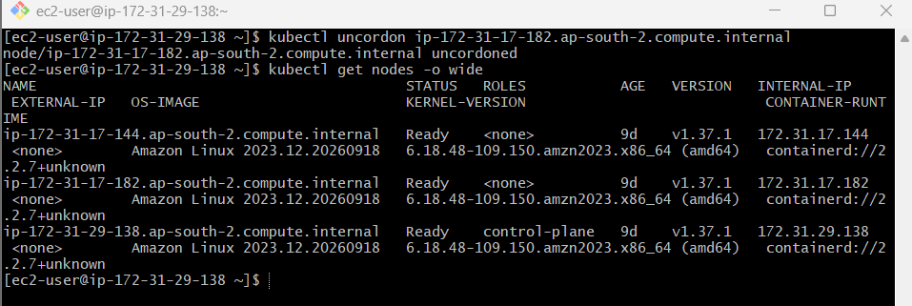
Then:
kubectl get pods -A
and:
kubectl get nodes
